IIPSGP BELTANE NEWSLETTER

MAY 1ST 2010

Here the sun is shining and the woods were radiant with bird song this morning. All is well here in West Sussex, new home to IIPSGP.

A general election is coming up in the UK on May 6th, of great importance nationally. Who to vote for ? This is the question ? Should we go on voting into power a corrupt Labour establishment who spout political righteousness yet actually who seem to have totally lost their moral compass, and whose value system seems to be based simply on being “anti-Tory” ?

Gordon Brown’s utter hypocrisy was revealed last week in his private comments calling an ordinary former Labour voter with genuine concerns about levels of immigration into the UK a “bigoted woman”.

The three leaders debates were an interesting exercise, but by general consensus David Cameron came away the overall winner, with a clearly articulated vision of where to take the country, and how.

One cannot however envy the man the gargantuan task facing him and his party as they survey the wreckage left after 13 years of Labour red tape, political correctness and marginalia.

My former students at St Marys in Calne asked me to record a party political broadcast for the Conservative Party, standing in mock school elections, and I did so, but didn’t actually tell them which party to vote for, but rather told them to vote for whichever party seemed to stand for the broadest, most spiritually intelligent policies, and which seemed to be based on ethical common sense and a sense of human goodness. I let them to make their own moral deductions.

Many people wonder why one should vote Conservative then, given that for years and years anti-Toryism has been something of a national sport in certain sections of UK society. Not surprisingly many young people, who have been deprived the benefits (or responsibility) of an actual education in history, and instead treated to project based sound bytes of pastness (castles, Romans, Tudors, Victorians, World War Two, World War Two, and World War Two…) will be totally bedazzled by the choices on offer, and probably opt for the Liberal Democratic Party because they sound (arguably) the nicest and most moral. But when you scratch the surface you find their policies include: abolishing the pound, joining the Euro, legalizing a large number of illegal immigrants to the UK, and innumerable other strange and quixotic gestures. Clegg simply doesn’t seem to have a sense of the country that he hopes to lead, and his identity as a convinced Eurocrat has been exposed to all who care to read the small print. Personally, I also blame the Liberal Party for getting Britain into World War One on the wrong side, when we should have been neutral, like Sweden (I used to nurse people who had fought in this war back in Canada and they swore me never to forget the suffering it had involved, which is why I set up IIPSGP in the first place.)Millions of deaths can be laid directly at the door of the Liberal Party, and that was also done in the name of progress and political correctness. As Wilfred Owen said (to paraphrase him), how sweetly and with what perfect harmony their old lies were said…

Whilst there are undoubtedly some good and intelligent candidates amongst the liberals, my own advice would be to vote tactically on an anti-Labour strategy, i.e. vote for either Conservative or Liberal if they are most likely to dislodge a sitting labour MP. If it was up to me, there would not be a single Labour Party candidate returned at this election. I would rather have some intelligent Greens, and UKIP members returned instead of Labour !

They have brought the country into utter contempt internationally; they have totally sold out all sense of fair play and morality in international relations by joining the illegal war against Iraq; they have failed abysmally to call for any real inquiry into the events of 9/11 but have totally gone with the theory that somehow the evidence of internal collusion among the US or other intelligence agencies can be air brushed under the carpet. They have also tried to enforce their own moral relativism on the country as a whole and make it increasingly difficult to hold to the ancient faiths which this country has immemorially held to (Christianity, ancient pagan and Druid faiths for example). Secularisation has been trumpeted as the imposition of a non or anti religious agenda on all public bodies, and like smoking, (which at heart was a religious custom introduced by White Buffalo Calf Woman to help the people survive famine) religion has been virtually abolished from public discourse, except as mere tokenism and a show of multiculturalism when it looks good.

They have failed to manage our national economy by failing to invest intelligently in the UK’s own actual citizens, traditions, skills and energies. Instead, innumerable small businesses have gone bankrupt and struggle to make ends meet, and the enormous amounts of red tape they have to comply with forces them to become pen pushers in the name of political correctness rather than entrepreneurs, innovators and visionaries.

We need a country which is dedicated to prosperity, intelligence, vision, wisdom and peace. This can only be a country where its citizens are dedicated to morality, to ethics and to the moral norms and values that hold society together. We need a country where it is not illegal to actually have a spiritual faith and to express your identity in a creative and loving way.

So, as in my election broadcast to St Marys School, it is not my business as Director of IIPSGP to tell friends, colleagues and members who to vote for, but rather, simply to urge colleagues to reflect on Kant’s ethical framework for difficult choices, and to vote from principle and duty, not from the mere calculation of short term political advantage. And to remember Kant’s motto – Sapere Aude – Dare to be Wise…

On another matter, whatever the outcome of the election, a new IIPSGP course is starting on May 30th, and will be taking place at monthly intervals in Chithurst, West Sussex. The details are as follows and I sincerely hope you will be able to attend. Space is limited however, so do book your place in advance and register to ensure a seat.

TRANSPERSONAL HISTORY:
TOWARDS A MAP OF A NEW COUNTRY -
FOOTNOTES TO THE PERIODIC TABLE OF THE WORLD’S RELIGIOUS AND PHILOSOPHICAL TRADITIONS

This special 2010-2011 course of lectures is being given by Dr. Thomas C Daffern, an academic specialist in interfaith research and comparative global philosophy. It is taking place in West Sussex, close to the Buddhist monastery at Chithurst, and is being given to an invited audience. It will be audio-recorded as a record of the proceedings. The cost of admission is by donation. The talks will be taking place on Sunday afternoons, on the last Sunday of each month, from 3-5.30 starting in May 2010. They will be followed by questions and discussion of the issues raised. The course is based partly on the unique Periodic Table of the World’s Religious and Philosophical Traditions devised by Dr Daffern (www.thewisdompages.co.uk) The course is also based on Dr Daffern’s doctoral thesis, entitled Toward a Transpersonal History of the Search for Peace 1945-2001 If you wish to attend please contact iipsgp@educationaid.net for an invitation and exact travel details. More details of Dr Daffern’s work are on www.educationaid.net while his publications are available from www.lulu.com/iipsgp. The course is taking place under the auspices of the International Institute of Peace Studies and Global Philosophy and all students, members and friends of the Institute are especially welcome.

1 | May 30 – Introduction: Transpersonal history – defining a new discipline
2 | June 27 – Jung, Freud and the founding of the transpersonal approach in depth psychology and psychohistory
3 | July 25 – Jungians and the transpersonal: Hillman, Joseph Campbell and beyond
4 | August 29 - Maslow, Assagioli, Groff, and transpersonal history
5 | September 26 - Ken Wilber, Integral theory and transpersonal history
6 | October 31 - Intellectual history and transpersonal history
7 | November 28 - The periodic table of religions and philosophies and transpersonal history
8 | December 19 – Genres of history – diplomatic, political, social, economic, gender, cultural, materialist, and transpersonal history
9 | 2011 - Jan 30 - Psychohistories and transpersonal history: De Mause, Erikson
10 | Feb 27 - Theosophy, Anthroposophy, esotericism and historiography and transpersonal history
11 | March 27 – History of religions and spirituality – Eliade, Smart etc. Sufism, Kabbalah, Christianity, Buddhism, Druidry, Jainism, Hinduism, New Age, gnosis and transpersonal history
12 | April 24 – History of sciences and transpersonal history
13 | May 29 – History of global philosophies and transpersonal history
14 | June 26 – History of the Arts, inspiration and transpersonal history
15 | July 31 – Peace history, conflict resolution, the Middle East, the Afghan War and transpersonal history – by way of a conclusion which is not the end…

Now after that rainbow of possibilities, a few closing words: in the move of IIPSGP from Wales to West Sussex, some hundreds of documents seem to have been lost, which is a catastrophe as it is included the files of letters and correspondence of IIPSGP’s early years from 1991-2000. Help is needed however to help salvage and sort out what remains, and the many files and documents which were successfully transported (thanks to all who helped the move) are still awaiting sorting and classification and shelving in our new centre, so any volunteers who can spare the odd Sunday to come and help are most welcome.

Some friends may also be aware that I have been awarded the Mount Haemus Scholarship this year, by the Order of Bards Ovates and Druids and will be preparing a paper examining the links between Druidry and Transpersonal Psychology and integral spirituality, to be delivered next year. Details are on the OBOD website at: www.druidry.org

In addition, as others are aware, I finally received my official PHD in a splendid ceremony at the Barbican in the city of London on March 15 2020, and enjoyed meeting the Vice Chancellor of the University of London and being at such a moving event, where some 1000 scholars all received their degrees, along with their friends and families in attendance. Here is a picture taken at the event with some dragons and an interesting Latin Motto (perhaps IIPSGP’s motto should read Musae Dirige Nos):

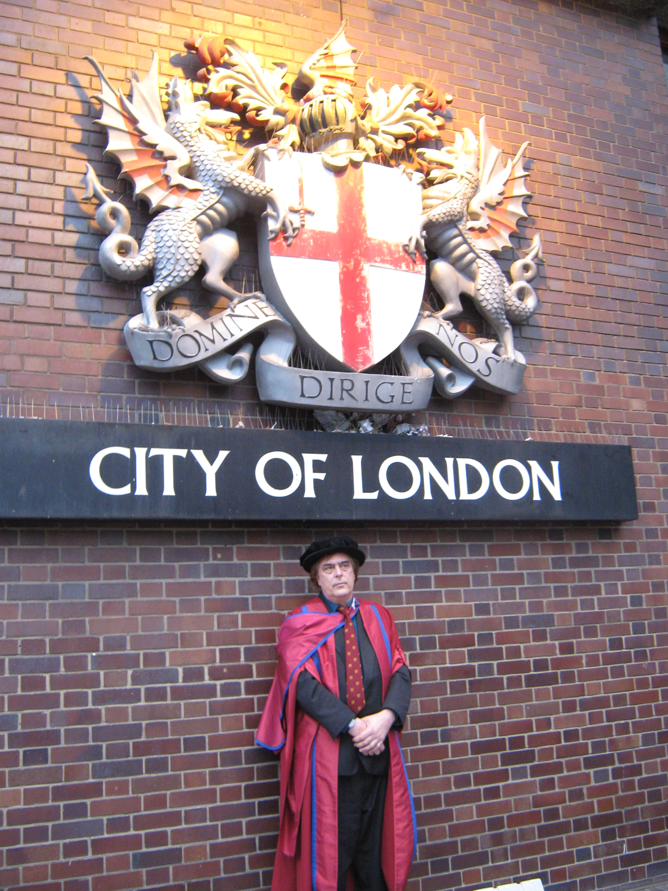

In conclusion then, it is perhaps also worth pointing out that IIPSGP Co-Chairperson, Lynne Sedgmore, recently came on a visit to Chithurst, and in the course of a long catch-up conversation, revealed that she had recently been doing some work with senior civil servants about he whole question of leadership, values and vision. How is it that we can learn to lead successfully ? Sometimes, Lynne and I agreed, it is best in a leader to admit they don’t know something, rather than pretend they know everything. She commented on Gordon Brown’s style of leadership, that he simply could never admit to not knowing, that he was utterly unable to delegate or to let go of control and power. Sometimes real power is about letting go, surrendering. On a recent visit to my daughters in Brighton, I found a beautiful Mosque, Al Madina, in a quiet back street, and would remind friends that real spiritual surrender remains an elusive goal for all of us. Our Reason, as Kant would say, requires us to find authenticity and to find the real Divine, before it will or can actually surrender. Likewise, I recently experienced something of a realisation that it would be a good idea to present an Anglo-Afghan Peace Plan, since that conflict remains intractable and a very messy and brutal war – which is my view could be totally sorted tomorrow if both sides simply surrendered to the higher spiritual power that actually runs this universe, call it Allah, God, Christ, Tao, Buddha Nature or whatever. For centuries, Afghanistan was a Buddhist heartland, and Padmasambhava, who brought Tantrism to Tibet, actually is thought to have come from there, when the country was known as Uddiyan. Some of my former students are currently living in Kabul and trying their best to bring peace there. (On Padhmasambhava check out: http://www.lawoftime.org/noosphere/nooarticles/theabsoluteisalreadycomplete.html)

IIPSGP remains dedicated to international peacemaking, through the exploration and discussion and analysis of shared moral, spiritual and intellectual values, believing that the power of philosophy and the art of dialecticism can be more creative than the destructive power of mere weaponry.

Similarly the crisis facing Greece at present, homeland of the Muses, is of such a scale that sorting out the economic mess not only of the UK, but all of Europe, and indeed the USA as well, remains a core commitment of IIPSGP, for without economic well being and prosperity, there can be no lasting peace. But we also take the view the crisis is not simply an economic one, which can be resolved by more economism – rather, the whole problem affecting the globe is a paradigm shift of great potential, in which the old paradigms of homo economicus are being challenged, and we have to get back to a world in which morality, ideas, visions, spirit, faith, philosophy, thought, love and Being itself, are also important, not mere money, income and debt slavery. Nobody has time to simply Be anymore – have you noticed ! There’s got to be something wrong with such a system ! Listen to the elders of the planet speak about this, as they gather in the sacred heartlands of the American Indian peoples, in the run up to their cosmic realignment time of 2012 – see http://www.ica8.org/

Several new publications have been forthcoming from my own pen in the past 12 months, since the last IIPSGP newsletter was published, which are mostly available via the website www.lulu.com/iipsgp.

A full IIPSGP Muses Journal is currently in final preparation and will be published later in the Summer.

Other good news: Former IIPSGP London Secretary, Maria Matulewicz, has been appointed PA to the Dean of the Melbourne College of Divinity, in Australia, and takes up her appointment shortly. Arlene Murdock of Massachusetts has also agreed to represent IIPSGP in that part of the world. Jeffrey Gale, eco-architect, has agreed to represent IIPSGP’s idea of the Spiritual Pilgrimage centre near Stonehenge to English Heritage, and has drawn up some detailed designs of what such a centre would look like. Hannah Hawker has given birth to a healthy son down in Bournemouth with her partner Robin ! Helen Craig-Daffern’s own son is coming up to two years old, and she is doing well in her Sussex University degree, becoming more and more interested in the scientific study of consciousness. A new website is also being developed by IIPSGP Media Director, Nicola Hague, which we hope will carry audio interviews with leading scientists and thinkers from around the world in discussion. Elizabeth Kempe, IIPSGP International Secretary is also continuing to run her cultural gatherings in Powys, with the help of IIPSGP General Secretary Mary Napper, and various poets and musicians and artists are involved. Mary is also working on an excellent scheme to give artists throughout Powys mentoring and support in their professional careers.

It should also be noted that I am taking part in the Pagan Esoteric Fair in Ludlow, at the Assembly Rooms, Shropshire on Saturday May 29th (see www.myddle-earth.info) and giving a talk entitled “Paganism and Transpersonal History” which should be great fun and hopefully of interest to the many magical people in that part of the world. Ludlow is of course where the Council of the Marches was based for many years, and in its superb castle Sir Philip Sydney’s father used to live. If you’ve never visited Ludlow, now is your chance – and do go to the Castle and climb to the very top from which stupendous views can be had. Its also where Arthur Tudor, elder brother of Henry 8th lived with his young wife from Spain, Catherine of Aragon, and where he also sadly died far too young.

The Summer solstice events on June 20/21st will be taking place as usual at Stonehenge, and IIPSGP will be once again organising a mini-Eisteddfod around that time, for which colleagues are welcome to submit entries as usual, either on their own or on other’s behalf. This time it will probably be taking place as part of the overnight activities themselves. Please apply for further details. Finally, Anna Baker has continued to develop the new website www.thewisdompages.co.uk which carries the informative Period Table of the World’s Religious and Philosophical Traditions, and which is a resource that can be used by schools, colleges universities, and individual scholars and seekers all over the world. Do please join up to the Wisdom Forum and use it to share ideas and news items if you haven’t already done so. More sadly, Gila Haron, who organises IIPSGP’s work in Israel, has announced the sad death of her spiritual mentor, Menorah, but her work lives on, and we were fortunate in capturing her in a long video interview in 2007 about her understanding of the path to spiritual peace between Israel, Palestine and neighbouring states. The work of IIPSGP’s project the Truth and Reconciliation Commission of the Middle East is due to be renewed later in 2010 with a further visit to that troubled region.

Finally, it should be added that IIPSGP active project of a Centre for Peace Policy Research remains the only academic framework which is prepared to actually articulate, expound and analyse a possible peace policy for the UK and internationally. No other think tank is even using this term as of now: we have social policy, family policy, military policy, spending policy, foreign policy, defence policy, strategic policy, health policy, education policy etc. All of these are important. But IIPSGP argues they need to be complemented by rational discussion of a peace policy. This was what was missing in the run up to the invasion of Iraq (no realistic peace plan on the table) and even in the invasion of Afghanistan. On the question of nuclear deterrence there is now more open debate about the wisdom of renewing Trident, and if not, then what are the alternatives. Likewise, on preventing future wars and solving the Afghan conflict, there is much still to do. It will take along time to clear up after the incompetence left by the Labour Governments since 1997. Above all, there are questions about Labour’s misuse of intelligence for party political ends, and Liberal Democrat MP Norman Baker is still rightly asking awkward questions about the death of Dr David Kelly. IIPSGP stands for replacing secret unintelligence with public wisdom, and has never been afraid to ask awkward questions of those in high places. Whoever wins the elections on May 6th we anticipate holding some more seminars about Ethics and Peace Policy in the House of Lords in the coming months, where the whole question of a lack of joined up peace policy can be debated and discussed in the open. It remains one of IIPSGP’s stated objectives to see a national centre for peace established in London, as an all-party project, funded by a percentage of the MOD’s annual budget, is the US Institute of Peace.

Any other good news entries for the Muses Journal, or interesting things going on either academically or spiritually in your own domain that you wish to see included, please email them to us at the address below.

Meanwhile, Happy Beltane and Spring Blessings from myself personally and from everyone connected with the work of IIPSGP.

Dr. Thomas Clough Daffern,
Chithurst Lane, Trotton, West Sussex,
GU31 5ET,
Tel. 01730 716496
Email: iipsgp@educationaid.net
www.educationaid.net
www.thewisdompages.co.uk

